## Setup

To set-up the system, you need the special Windows configuration tool and a working version of NavVison (version 9.18.4.100 or higher). NavVision will be used to set-up the DAP’s and Wago’s (giving IP addresses) The configuration tool will be used to set-up the BNWAS part of the system.

### NavVision

Within NavVision the right IP addresses will be set for the Wago’s and DAP’s that are in the system. If not on board, a laptop can be used to set this up. Once the IP addresses are set they will be retained in the Wago or the DAP. Be sure to right down this addresses for future reference.

### BNWAS configuration tool

A special configuration tool for the BNWAS is available called “BCBNWAS.exe”. Put this file in a folder on your laptop together with the BNWAS.ini file we mentioned earlier. When double-clicked the following screen will appear:

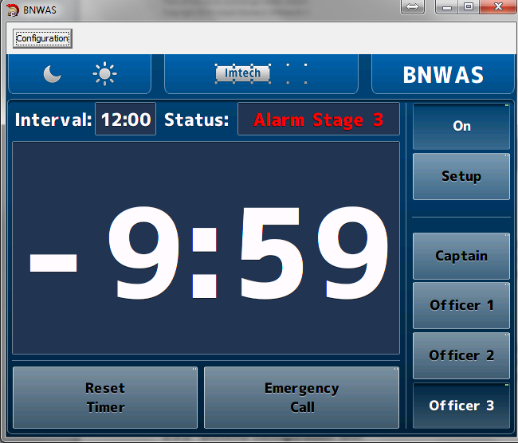

Figure 2‑47: BNWAS configuration screen

This looks exactly like the Standard BNWAS hmi with the only difference that it has a configuration button. When you click the configuration button the following screen will appear:

Settings that can be made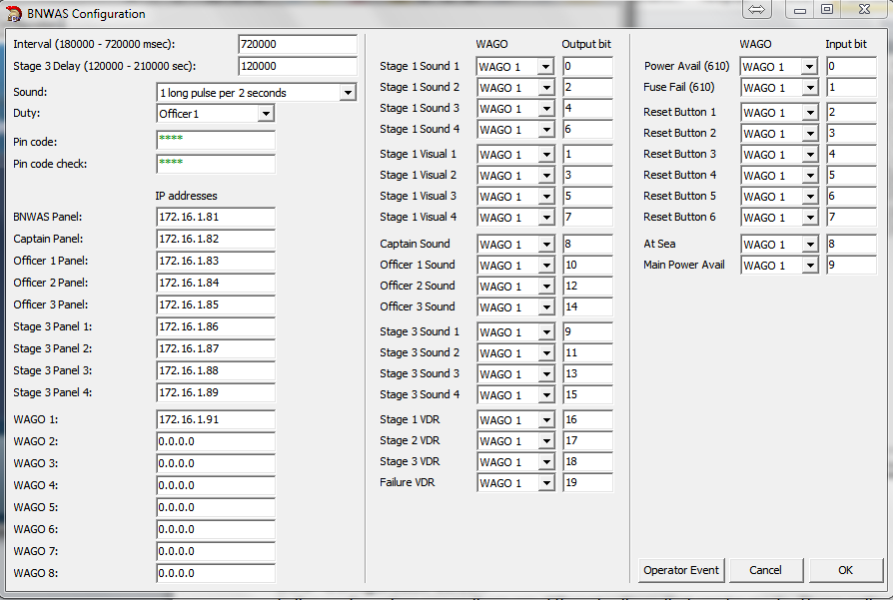

Figure 2‑48: BNWAS configuration screen

The different parts of this configuration screen will be discussed hereafter.

### Configuration screen

In the configuration screen there are different settings that can be made. These settings will be split up hereafter.

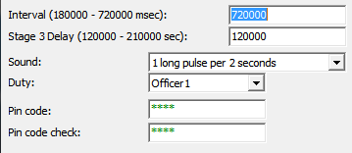

Figure 2‑49: General settings

In the general settings, the same settings can be made as can be done in the program itself under “setup”.

|  |  |
| --- | --- |
| **Setting** | **Detail** |
| Interval | Set interval of Td between 3 and 12 minutes (180000-720000 msec) |
| Stage 3 Delay | Delay of the stage 3 time between 2 and 3,5 minutes |
| Sound | Change the modulation of the alarm-sound |
| Duty | Select OOW on duty |
| Pin code | Set Pin code for setup |
| Pin code check | Pin code check |

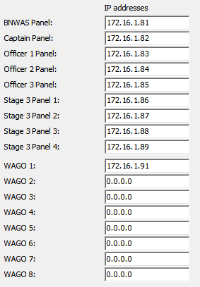

Figure 2‑50: IP address settings

In the IP address section, settings can be made to distinguish the different panels and WAGO’s. The main panel (the panel in charge) is always the BNWAS panel.

If used in the system other DAP’s can be set as 2nd or 3rd stage panels by selecting their respective IP addresses behind the right panel. There are four 2nd stage panels

* Captain panel
* Officer 1 panel
* Officer 2 panel
* Officer 3 panel

And four 3rd stage panels

* Stage 3 panel 1
* Stage 3 panel 2
* Stage 3 panel 3
* Stage 3 panel 4

The IP addresses of the DAP’s and the WAGO’s are first set in NavVision. Corresponding you can set these IP addresses to the right DAP panel or WAGO.

*: If no other DAP or WAGO is used, leave the IP addresses at 0.0.0.0*

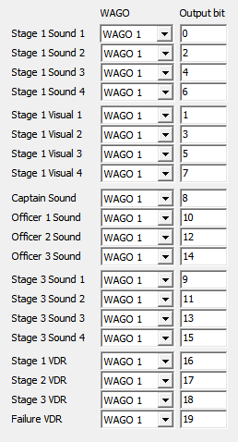

Figure 2‑51: Wago output bit setting

The Audible and visual outputs are set here. Each output represents a stage of the BNWAS system. These outputs will be set on the dedicated Wago slice. There are 3 different stages of alarm outputs and a separate output to the VDR.

* Stage 1 Visual 1 (2,3,4) – output to the bridge visual alarms
* Stage 1 sound 1 (2,3,4) – output to the Bridge Audible alarms
* Captain, Officer 1,2,3 sound – combined visual and audible output to the duty cabin
* Stage 3 sound 1 (2,3,4) – combined visual and audible output to the 3rd stage places
* Stage 1,2,3, failure VDR – output to the VDR for mandatory alarms

In the column “WAGO” you can choose on which WAGO the connection is made. This depends on the order of the setup. Normally it is just 1 WAGO, so you can leave it as is. If the setup is divided over more WAGO’s The order is set by the IP range

* 172.16.1.91 = WAGO 1
* 172.16.1.92 = WAGO 2
* 172.16.1.93 = WAGO 3
* Etc

In the column “Output bit” you can set the exact pin on the particular slice where that field is connected to.

*: Notice that for the Output bit we count via the internal program of the WAGO. So we count all the available outputs from the beginning of the WAGO (see* Figure 2‑53*)*

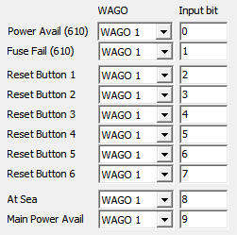

Figure 2‑52: Wago Input bit setting

In the column “WAGO” you can choose on which WAGO the connection is made. This depends on the order of the setup. Normally it is just 1 WAGO, so you can leave it as is. If the setup is divided over more WAGO’s The order is set by the IP range.

* 172.16.1.91 = WAGO 1
* 172.16.1.92 = WAGO 2
* 172.16.1.93 = WAGO 3
* Etc

In the column “Input bit” you can set the exact pin on the particular slice where that field is connected to.

*: Notice that for the Output bit we count via the internal program of the WAGO. So we*

*count all the available outputs from the beginning of the WAGO (see* Figure 2‑53*)*

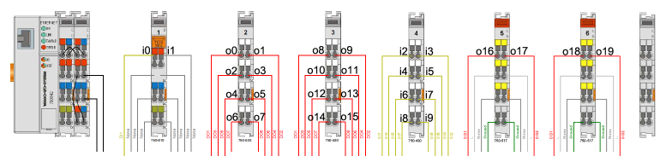

Figure 2‑53: Input Output counting Wago (i=Input, o=Output)